EXPERIMENT NO # 03
Name: vishaka Date: 3-April-2026
Score: __________________________________Signature of Instructor___________
Ohm’s Law
OBJECTIVE: To verify Ohm’s Law.
Apparatus:
- Multimeter,
- apparatus for resistance measurements,
- AC/DC Power supply 0 -12 V,
- Connecting Leads,
- Breadboard,
- Few Resistors
THEORY:
Ohm’s Law is the most widely used principle in the study of electrical engineering. In 1828, George Simon Ohm experimentally found that the amount of current in a circuit depended upon the amount of resistance R and the amount of voltage V. If any of the two factors R, V, I are known the third can be easily calculated as; I=V/R, V=IR, R=V/I.
Ohm’s law is usually represented by the equation I=V/R. Because it is a mathematical representation of a physical occurrence, it is important to note that the relationship between three factors V, I, R can also be stated as follows:
Current is directly proportional to voltage if the resistance does not vary.
Current is inversely proportional to resistance if the voltage does not vary.
PROCEDURE
- Make the circuit as shown in Figure.1 by properly connecting the power supply, voltmeter and ammeter.
- Now calculate the values of current for different voltage readings and constant resistance and write them in the Table.1 under calculated value of current.
- Now turn the power supply on and measure different values of current at different voltage readings and record your result in the Table.1 under measured value of current. But make sure the resistance is kept constant.
- Complete the Table.1 by taking all the values for current.
- Similarly fill the Table.2 by measuring the different values of current but here the voltage should be kept constant and resistance is varied.
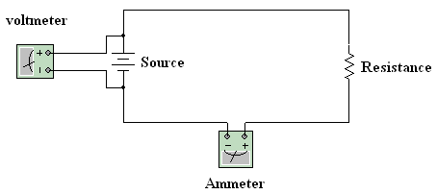
Figure 1

Table 1
Applied Voltage(V) | Resistance Value(R) | Measured Current(I) | Calculated Current(I)
12V | 1k | 12mA | 12mA
6V | 1k | 6mA | 6mA
15V | 1k | 15mA | 15mA
17V | 1k | 17mA | 17mA
23V | 1k | 23mA | 23mA
30V | 1k | 30mA | 30mA
35V | 1k | 35mA | 35mA
45V | 1k | 45mA | 45mA
50V | 1k | 50mA | 50mA

Table 2
Applied Voltage(V) | Resistance Value(R) | Measured Current(I) | Calculated Current(I)
12V | 500 | 24mA | 24mA
12V | 560 | 21.429mA | 0.021428A
12V | 450 | 26.667mA | 0.02667A
12V | 365 | 32.877mA | 0.03287A
12V | 1.07k | 11.215mA | 11.215mA
12V | 1.2k | 10mA | 10mA
12V | 1.96k | 6.122mA | 6.122mA

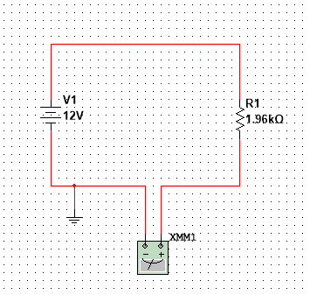
CONCLUSION
The experiment was performed successfully by measuring current for different values of voltage and resistance. It was observed that when resistance was kept constant, the current increased with increase in voltage and decreased with decrease in voltage. Similarly, when voltage was kept constant, the current decreased as resistance increased and vice versa. The measured values were close to the calculated values. Hence, the results verify Ohm’s Law (V = IR).

